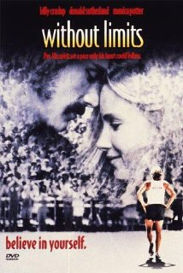
Without Limits
Writing Prompt: After Viewing “Without Limits”, what was your take-away (lasting impression) of the connection between Steve Prefontaine (the world class distance runner), and Bill Bowerman (the University of Oregon Track Coach and founder of Nike)? Would there ever have been a Nike without the influence of Steve Prefontaine? Would there ever have been a running boom without the influence of Steve Prefontaine? Does Nike’s theme, “JUST DO IT” emanate from Pre’s philosophy of believing in yourself? Please write 3 – 5 paragraphs with your thoughts and impressions. (100 points)

