**Time Value of Money**

Directions: as you watch the presentation on “Time Value of Money,” answer the following questions:

Interest is extra money you receive by placing your money on deposit at a ____________.

Compound Interest means that you receive _______________ on interest.

The Time Value of Money:

Because you can receive ____________ on any money you have, money received __________ is worth more than money received in the ________

An example of compound interest: If you have $1000 invested at 10% interest, how much total money would you have after one year?

$________________

During the second year, you receive interest not only on your original investment, but you also receive interest on the interest. For the second year, you will receive 10% interest not on $1000 (your original investment), but on $1100 (your original investment + the interest you received the first year). What is your total money after the second year?

$________________

Simple interest is interest earned on the __________________________________________.

The principal is the ____________________________________________________________.

An example of simple interest (you don’t get interest on the interest): If you have $1000 invested at 10% simple interest, how much total money will you have after the first year?

$________________

How much interest will you receive the second year (remember that you receive interest only on your original principal, not on the interest you receive)?

$________________

Note that you get the ________________ amount of interest every year because you are always just getting interest on the original principal.

In our example, how much extra money would you receive through compound interest as opposed to simple interest?

$________________

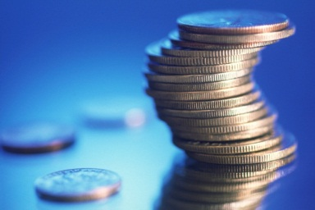

Explain the value of TIME in compound interest:

The __________________________ an individual invests, the more ________________ the investment has to compound interest and increase in _____________________.

Why is it important to invest only a small amount rather than nothing at all?

______________________________________________________________________________

The larger the amount invested the ____________________ return a person will earn.

Savings should be a ___________ expense, and you should always _______________________.

The 70-20-10 Rule states:

__________% for spending __________% for saving __________% for investing

What kinds of expenses can you decrease in order to increase savings/investing?

C:\Users\marykay.scholl\AppData\Local\Microsoft\Windows\Temporary Internet Files\Content.IE5\JLCW4WDN\MC900214929[1].wmf

___________________________

Does a person want a higher or lower interest rate on investing or savings? _____________

Why? The ____________________ the interest rate, the ____________ money earned.

________________ is the uncertainty of the outcome of an investment.

An example of the risk principle is investing money in ______________________________. Usually you will get a higher return, but it is also much ________________________. You may ______________ more money than you ____________.

Generally, the ________________ the potential interest rate the __________________ the risk.

A fixed interest rate means that the interest rate will ____________________ for the lifetime of the investment.

What is the risk you take with a fixed interest rate? _____________________________________________________________________________

Inflation is the _______________________________________________________________.

Give an example of the risk you have with inflation and investing/saving your money:

_____________________________________________________________________________

Define the following:

MCj03832560000[1]

Present value (PV):

__________________________________________________________________

Future value (FV):

__________________________________________________________________

Interest rate (i):

__________________________________________________________________

Time (N):

__________________________________________________________________

Open your Internet browser and go to the following website: **moneychimp.com** and click on the Calculator tab.

It will look like this:

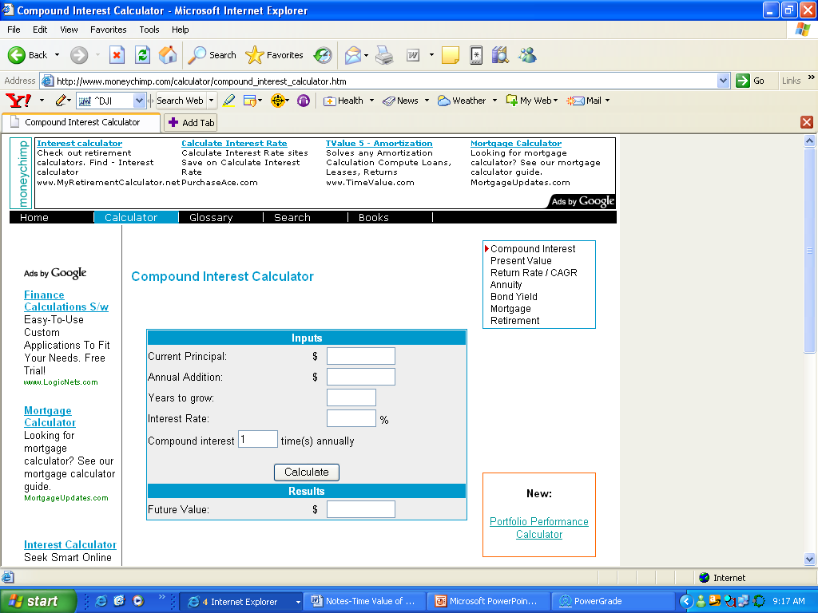

To see the power of compound interest, you will enter some numbers into the calculator and the calculator will show you how much your money will increase over time.

For example, if you saved $500 a year for 40 years, how much will you have about the time you are ready to retire? Enter the following into the calculator:

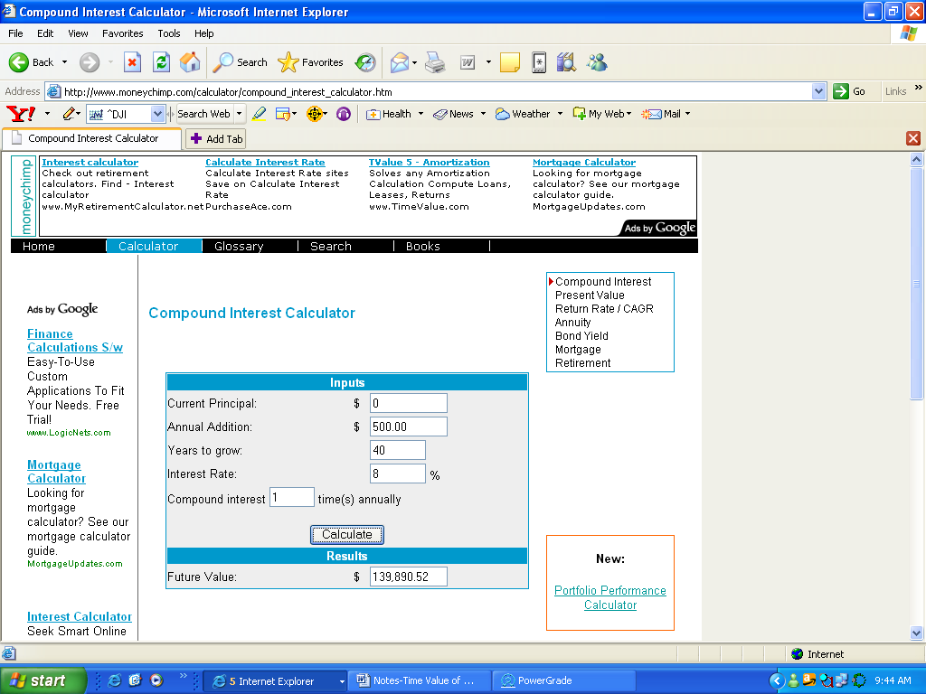

$500 per year

40 years

8% interest

Click **Calculate**

Future value (or the amount of money you will have based on these figures):

Now, change the figures and recalculate. What if you could get 11% interest, which is what the stock market has returned on average over the last 70 years? Leaving everything else the same, change the interest rate to 11% and recalculate. How much money would you have?

$________________

How about if you could save more money? Leaving everything the same, change the annual addition to $1000. How much money would you have?

$________________

What if you saved $1000 for 50 years instead of 40 years? Leaving everything else the same, how much money would you have?

$________________

What if you saved your money in a CD (Certificate of Deposit) instead of investing in the stock market, and you got only 5% instead of 11%? Leaving everything else the same, change the interest rate to 5% and recalculate. How much money will you have?

$________________

What if you saved your money in a typical savings account rather than a CD or in the stock market? Leaving everything else the same, change the interest rate to 2% and recalculate. How much money will you have?

$________________

Try a few other numbers and watch what happens to your money as you change the variables. Then answer these questions:

How does your ending total change when you increase the length of time you save/invest?

How does your ending total change when you increase the interest rate you are able to get?

How does your ending total change when you increase the amount of money you are able to save/invest?

What is the most important thing you learned from this assignment?