**Financial Literacy**

**Tax Preparation**

[](http://images.google.com/imgres?imgurl=http://www.bossard.lib.oh.us/taxes.jpg&imgrefurl=http://www.bossard.lib.oh.us/legal.html&h=552&w=720&sz=37&hl=en&start=8&tbnid=4aoi0oKO0YKRdM:&tbnh=107&tbnw=140&prev=/images?q=taxes&gbv=2&hl=en)

**Directions**: as you watch the presentation on tax preparation, complete the following notes.

Is the federal income tax a progressive or regressive tax? __________________

That means that the __________________ your income the ______________________ you are paying in taxes, both as a total amount and as a percentage.

About what percentage of your income goes to pay taxes? _______**%**

**Tax Vocabulary:**

**Tax brackets** are ______________________ in which the same tax rates apply. For example, you will be in one of these brackets, depending on your income

* _____**%**
* _____**%**
* _____**%**
* _____**%**

A **personal exemption** is an allowed ____________________ in your income before taxes are computed

Who do you get personal exemptions for?

1. __________________
2. __________________
3. __________________

**Deductions** are _____________________ that reduce taxable income. [](http://images.google.com/imgres?imgurl=http://www.southplainfieldnj.com/SeniorCenter/Taxes.1.jpg&imgrefurl=http://eugeneoregonhomes.blogspot.com/2007/02/change-homes-move-office-earn-tax-break.html&h=566&w=800&sz=52&hl=en&start=15&tbnid=AHgzBE-niQj00M:&tbnh=101&tbnw=143&prev=/images?q=standard+deduction&gbv=2&hl=en)

Examples of deductions:

1. ____________________________
2. ____________________________
3. ____________________________
4. ____________________________

The **standard deduction** is a set deduction allowed by the __________ regardless of your actual expenses.

You can ___________________ deductions or take the _______________________________, but not both.

**Taxable income** is income subject to _________ after _________________ and _________________ are subtracted from _____________________.

**Tax Example:**

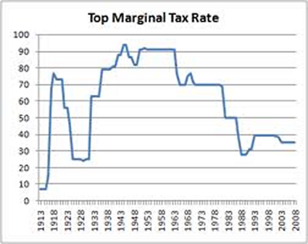**Marginal tax rates** are the ________________________ paid on your _______________________ level of income.

In our example, the marginal tax rate is _____**%**

From the Fiscal Cliff agreement, what is the current highest marginal tax rate? ______**%**

The **average tax rate** is your ______________ taxes divided by your ______________________. In our example, it is **$**__________/**$**____________ = _______**%**

Or by your total income: Your actual taxes divided by your ______________ income. In our example, it is **$**__________/**$**___________ = ______**%**

**Filing Status**

If you are **single** at the end of the year with no dependents, you can file _________________________ .

If you are **married** at the end of the year and you and your spouse combine your incomes, you can file _____________________________________ .

If you are married at the end of the year, but you and your spouse do not combine your incomes, you can file _______________________________ .

If you are unmarried but have at least one child living with you, you can file _______________________.

**Other taxes you pay:**

* Social Security (FICA) is ____**%** for Social Security and ______**%** for Medicare.
* State and local income taxes
* **Excise taxes** for things such as:____________ taxes, __________ taxes, _________________ taxes, taxes on _________________, ____________________, _____________________, _________ travel, etc.
* **Gift** and ______________ taxes

**Who Has to File a Return?**

* You must file a return if your income is greater than **$**____________.
* If it is less than that, you might not need to file, depending on your ______________________ (check with your tax advisor
* However, if your income is less than that and if you had _______________________, you will not get a _________________ unless you file a return.

**Itemizing Deductions:**

The most common itemized deductions are:

1. _____________ and ________________ expenses that exceed ______**%** of your adjusted gross income
2. Tax expenses (__________ and ____________ can be deducted, but not ________________, _________________, _________________, or _____________ taxes)
3. 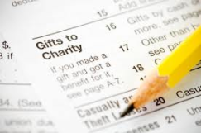 Home ____________________ interest
4. Charitable _______________________
5. _______________ and _____________ losses

A deduction will lower your tax bill, but not ________________ for _________________.

The standard deduction is the government’s best estimate of what the _________________________ would be able to deduct by itemizing.

Remember that you can take the ______________________________ or you can __________________, but you can’t do both.

**Exemptions:**

You can take a personal exemption for yourself and for your spouse, plus you can take exemptions for your dependents. The rules to qualify as a dependent are:

1. Must have a qualifying relationship (_____________, ________________, ________________, step-_________________, uncles, nieces, etc.
2. The dependent can’t earn more than the _________________ amount. Exception: this does not apply to children under the age of ______ or under ________ if full-time students
3. Must provide over ___________ of the dependent’s financial support

**Tax formula**

The tax formula is _________________________ less ___________________________ equals ___________________________ less ____________________________ equals _________________.

For most taxpayers, the tax is calculated using _______________________. Tax tables have tax _________________ built in

**Income tax credits:**

Explain these income tax credits:

Tax credits will lower your tax bill, __________________________________________

Explain these credits:

**Child Tax Credit**: (this can be a ________________ for parents who don’t pay taxes) up to **$**________ per child

**American Opportunity Credit**: This is a credit for _______________, up to **$**__________ of the first **$**__________ of educational expenses

**Child and Dependent Care Credit**: This is a credit for money paid for __________ or other _________________ care

**Earned income credit**: For low-income families, this may result in _______________ taxes paid

**Income Tax Due:**

The formula for income tax due is ______________________ less tax _____________ equals _________________________________.

**Picking a tax form:**

The **1040EZ form** can be used if you have no ________________; your taxable income is less than **$**______________, and no ________________ deductions

The **1040A form** can be used if you have no ___________________, ______________, capital _________, pension or Social Security _______________; and income less than **$**___________.

****The **1040 form** is used by ________________________