Name:___________________________ Period: ___ Date: _____________

[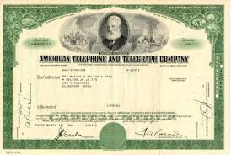](http://images.google.com/imgres?imgurl=http://i.investopedia.com/inv/tutorials/site/stocks1_certificate_big.jpg&imgrefurl=http://www.investopedia.com/university/stocks/stocks1.asp&h=294&w=437&sz=23&hl=en&start=12&tbnid=3T01vCIFsJV7EM:&tbnh=85&tbnw=126&prev=/images?q=stocks&gbv=2&svnum=10&hl=en)

**Stock Market Basics**

1. What is the definition of a stock?

1. What is the definition of a bond?

1. **Explain** the difference between buying a stock and buying a mutual fund: Buying a stock is buying an interest in only _________ company. Buying a mutual fund is buying an interest in __________________________________________
2. What are two of the advantages of mutual funds?

MCj02979430000[1]

______________________________________________________________________

MCj02979410000[1]

______________________________________________________________________

1. What are two reasons companies issue stocks?

MCj02979430000[1]

______________________________________________________________________

MCj02979410000[1]

______________________________________________________________________

1. Why do people buy stock?

1. Generally, stocks provide a higher return than other investments. We can also say that the **higher** the rate of return, the **higher** the risk, so what can you say about the risk of investing in the stock market? Is it very risky or not very risky?

1. Ways the stock value can change:

MCj03400000000[1]MCj03260940000[1]MCj03260920000[1]MCj03260900000[1]

______________________________________________________________________

1. If you had 500 shares of stock worth $12.00 a share, how much would your total investment in the stock be? (**Hint**: number of shares X value per share) $___________
2. If the stock split 2 for 1, how many shares would you have after the split? $_______
3. What would the stock price per share be after the split? $___________
4. What would be the value of your total investment in the stock be after the split? $________

MCj03596890000[1]

1. Beta value measures a stock’s ______________________________ compared to overall changes in the stock market.
2. If a stock has a beta value of 1.5 and the market goes up 10%, by what percentage would you expect the value of the stock to rise? (Hint: market percentage increase X beta value) ________**%**
3. If the beta value is 2.0 and the market goes up 10%, by what percentage would you expect the value of the stock to rise? ________**%**

MCj03636440000[1]

1. When interest rates go up, what generally happens to stock prices?

______________________

1. MCj02403950000[1]If a business is doing poorly, what generally happens to stock prices?

________________________________

1. If a company has too much debt, what generally happens to stock prices?

____________________________

1. If the stock market as a whole goes up, what generally happens to stock prices?

____________________________

1. The year-to-date percent change on a stock quote shows the change in stock prices since what date?

_____________________

1. The 52-week high & low shows price changes during what period of time?

____________________

1. What is a ticker symbol?

________________________________________________

1. What does dividends per share tell you?

________________________________________________

1. What is price/earnings ratio?

________________________________________________

1. If the volume on the stock quote reads 120, how many shares of stock were actually traded?

_________________

1. The high and low shows price changes during what period of time?

__________________________

1. What is the close price?

_______________________________________

1. What is the net change?

_______________________________________

Fill out the following information for a stock quote from Yahoo finance.

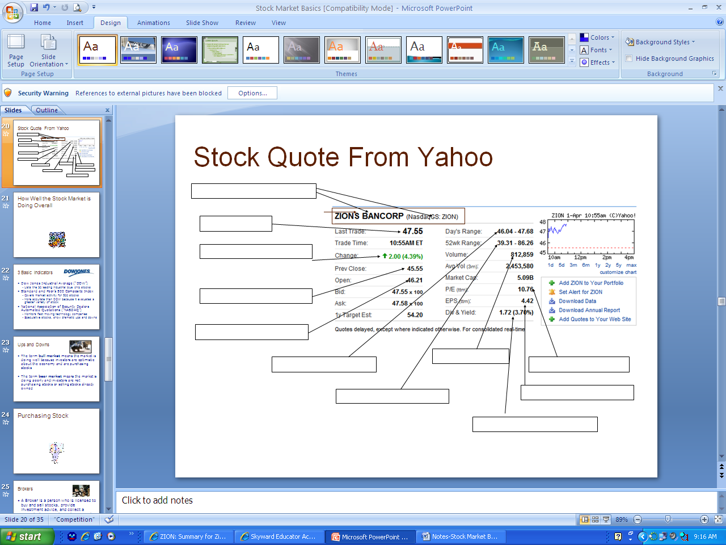

Stock Indexes:

1. What does the DOW track?

1. [](http://images.google.com/imgres?imgurl=http://www.investorspot.tv/web_pics/watermarked/Dow_Jones.jpg&imgrefurl=http://www.investorspot.tv/featured_pics.php&h=750&w=1000&sz=496&hl=en&start=3&tbnid=5TiwQZpKtWJ7UM:&tbnh=112&tbnw=149&prev=/images?q=dow+jones&gbv=2&svnum=10&hl=en)What does the S&P 500 track?

1. Which is more accurate—the DOW or the S&P?

1. Why?

1. What kinds of stocks are traded on the NASDAQ?

[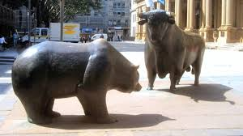](http://images.google.com/imgres?imgurl=http://upload.wikimedia.org/wikipedia/commons/thumb/0/0f/Bull_and_Bear_3.jpg/800px-Bull_and_Bear_3.jpg&imgrefurl=http://commons.wikimedia.org/wiki/Image:Bull_and_Bear_3.jpg&h=450&w=800&sz=76&hl=en&start=8&tbnid=OXvrpt7u7R7gLM:&tbnh=80&tbnw=143&prev=/images?q=bull+and+bear&gbv=2&svnum=10&hl=en)

|  |  |
| --- | --- |
| 25. What does a bull market mean?  ______________________________________ | 26. What does a bear market mean?  ______________________________________ |

[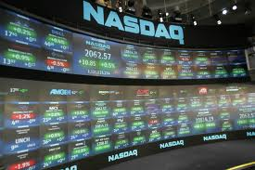](http://images.google.com/imgres?imgurl=http://roddzblog.files.wordpress.com/2007/01/nasdaq2.jpg&imgrefurl=http://roddzblog.wordpress.com/2007/01/&h=1400&w=2100&sz=305&hl=en&start=3&tbnid=JCC_l9rxejg6fM:&tbnh=100&tbnw=150&prev=/images?q=nasdaq&gbv=2&svnum=10&hl=en)

1. What is a broker?

Stock Exchanges:

1. What is a stock exchange?

1. Name three characteristics of the New York Stock Exchange:

MCj02979430000[1]

_____________________________________________

[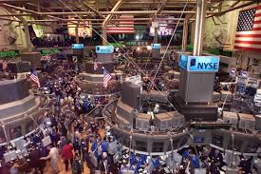](http://images.google.com/imgres?imgurl=http://icf.som.yale.edu/nyse/images/TradingFloor3.jpg&imgrefurl=http://icf.som.yale.edu/nyse/downloads.php&h=400&w=600&sz=107&hl=en&start=6&tbnid=ycg1j55PsYbSjM:&tbnh=90&tbnw=135&prev=/images?q=new+york+stock+exchange&gbv=2&svnum=10&hl=en)

MCj02979410000[1]

_____________________________________________

MCj02979390000[1]

_____________________________________________

1. [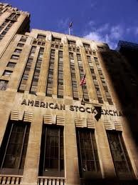](http://images.google.com/imgres?imgurl=http://upload.wikimedia.org/wikipedia/commons/thumb/2/20/American_stock_exchange_NYC.jpg/450px-American_stock_exchange_NYC.jpg&imgrefurl=http://commons.wikimedia.org/wiki/Image:American_stock_exchange_NYC.jpg&h=600&w=450&sz=75&hl=en&start=3&tbnid=dnrDM6AmCLEc3M:&tbnh=135&tbnw=101&prev=/images?q=american+stock+exchange&gbv=2&svnum=10&hl=en)Name two characteristics of the American Stock Exchange:

MCj02979430000[1]

_____________________________________________

MCj02979410000[1]

_____________________________________________

1. What is a regional stock exchange?

1. Name two characteristics of the NASDAQ:

MCj02979430000[1]

_____________________________________________

MCj02979410000[1]

_____________________________________________

1. The stock exchange is organized based upon the laws of ___________________ and __________________________.
2. If demand for a stock is high, the price will probably go ___________ because _________________________________________.
3. If demand for a stock is low, the price will probably go ____________ because _________________________________________.
4. Simply investing in the stock market will not guarantee that you will make money. There are over _________________ individual stocks and ________________ mutual funds.
5. Some suggestions to pick stocks are:

* Buy stocks in a company that you _________________________________________
* Suggestions (___________________) from people who are already investing.
* Suggestions from a ________________________________________

1. It is very risky to _________________________________________________________
2. Diversification means that you ______________________________________________
3. Name four Internet sites where you can go to get stock information: