Understanding Credit Reports Note Taking Guide

Name

Date

Credit is...
Class

__________________________________________________________________________________

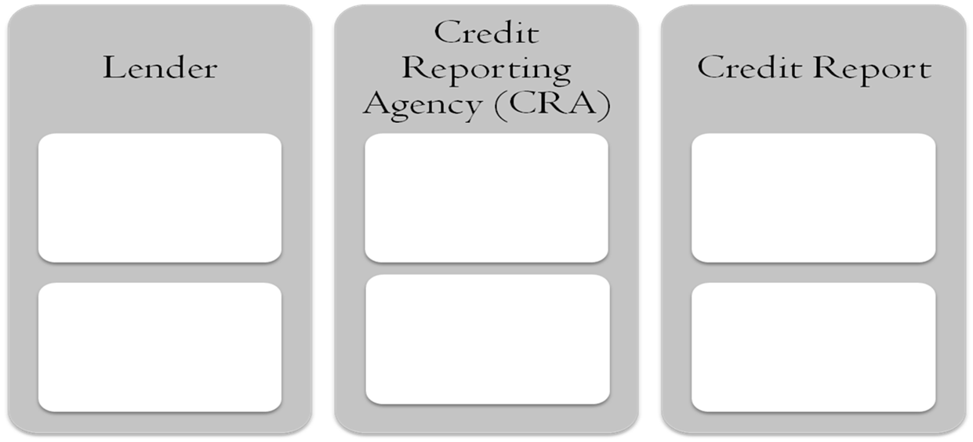
The Credit Process

- _______________
- _______________
- _______________
- _______________
- _______________
- _______________

What
__________________

__________________

__________________

they do:

- _______________
- _______________
- ________________
Additional
__________________

__________________

Information:

INFORMATION ON A CREDIT REPORT CAN BE DIVIDED INTO FOUR CATEGORIES:

_____________

_____________

_____________

_____________

INFORMATION ON A CREDIT REPORT CAN BE DIVIDED INTO FOUR CATEGORIES

•Personal
Information
- ___________
- ___________
- ___________
- ___________
- ___________
•Accounts
Summary
- ___________
- ___________
- ___________
- ___________
- ___________

- ___________
- ___________
- ___________
- ___________
- ___________
- ___________
- ___________
- ___________
- ___________
- ___________
- ___________
- ___________

•Public Record Items Related To Credit

•Credit
Inquiries

CREDIT
INQUIRIES
IMPACT

SOFT CHECK HARD CHECK

A hard check usually does ____________________
- ___________________
- ___________________
- ___________________
A soft check usually does ____________________
- ___________________
- ___________________
- ___________________
Not all credit inquiries are the same!
EXAMPLES

Medical Information NOT Allowed on a Credit Report:
Medical Information Allowed on a Credit Report
- ______________________________

- ______________________________
- ______________________________

EQUAL CREDIT OPPORTUNITY ACT PREVENTS DISCRIMINATION THE BASIS OF:

___________________ ____________________ ____________________
____________________ ____________________ ____________________
A credit score is: _____________________________________________________________
- Based on _____________________ in the ____________________________
- At a ______________________________ in time
- Numeric “________________” of a consumer’s ___________________________________
- Used by ____________ to determine a consumer’s risk of ___________________________

Most common credit score scoring system:
Range of scores is: to:

OUTSTANDING DEBT: Low
High

