Name: _________________________________ Period: ____ Date: ________________

Mutual Fund Basics

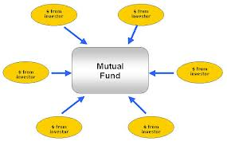
- What is a mutual fund?
  - Investors __________________ their money
  - A __________________________ buys a variety of stocks and other securities
  - Each investor owns ___________________ of the fund.
  - When the fund increases in value, the investor ___________________________.

- What is the price of a mutual fund called?

- How often are mutual fund prices updated?

- An open-ended fund may issue_______________________________________________

- __________ % of mutual funds are open-ended.

- A closed-end fund can issue

- Once those shares are sold, investors _____________ and _________________ shares among themselves.

- Advantages of mutual funds:

Diversification | - You purchase a small amount of _______________ stocks without having to physically _________________ each stock.
Professional Management | - Fund managers are __________________________ with access to _______________________________ than the average investor.
Minimal Transaction Costs | - Individual investors save on _______________________ compared to individual stock purchases. In a retirement account there is _____________________________________
Liquidity | - Mutual funds are easy to _______________ and _______________
Flexibility | - There are over _____________ funds to choose from, allowing you to invest in _____________________________________.

- Disadvantages of mutual funds

Lower than market performance | - On average, mutual funds _________________________ the market
Costs | - Mutual funds always charge _________________________ fee  - There may also be a _________________ fee  - These fees will __________________________________
Risk | - Depending on the segment of the market, your fund may _________________________ or __________________________
Systemic Risk | - A market crash will have a ______________________ effect on your fund
Fees | - _______________ funds charge a commission to buy or sell the fund.  - ________________________ means you pay a commission when you buy  - ___________________________ means you pay a commission when you sell
Annual Expenses | - Owners of mutual funds pay _________________________.  - This is called the _______________________________.  - Typically it is _______% to ________% of the investment value
Taxes | - Typically you have to pay _____________ on ________________ every year, except in a __________________________ account.
12b-1 Fees | - These are ________________________ expenses passed on to the ________________________  - They ___________________ benefit the investor at all.  - Try to find funds that have ____________________ or _________ 12b-1 fees

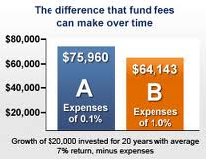

- Types of Mutual Funds – Stock Funds

Stock Funds | - Most ______________________ types of funds  - These funds invest mostly in stocks, but may also invest in ___________, _______________, and ________________________.
Aggressive Growth Funds | - This type of fund buys stocks that will ________________________ dramatically in price  - They are very ____________________.
Small Company Growth Funds | - Investments are limited to __________________________________.  - They are very _________________________.
Income Funds | - These funds concentrate on ___________________ companies paying _______________________. (The dividends are the _______________ in “Income” funds.  - They are less ________________ than aggressive growth funds
Growth and Income Funds | - These funds concentrate on stocks providing ____________________ plus the potential for __________________.  - Less _____________________
Sector Funds | - These funds specialize in stocks from a specific __________________ such as ___________________, ______________________________, ______________________, and ____________________________
International | - These funds invest mostly in stocks ______________________________
Balanced funds | - These funds hold both ________________ and __________________.
Asset Allocation | - These funds are ________________________ funds with ________________________________.
Life Cycle Funds | - These funds attempt to tailor holdings to the investor’s ___________ and _________________________.  - The fund is managed based on how ____________ to ______________________________ you are.

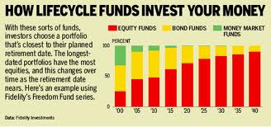

- Types of Mutual Funds – Bond Funds

- Types of Mutual Funds: Index Funds, or Exchange Traded Funds (ETF’s)

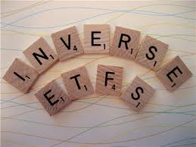
There are also _______________________ ETFs which will make you money when _____________________________________________. However, you will lose money when the market _____________________________.

- Buying a Mutual Fund

You can buy mutual funds at the following places:
- Purchase through your _____________________________________________________
- Purchase directly through __________________________________________________
- Purchase through your _____________________________________________________
- Purchase through your _____________________________________________________
- Many funds will let you invest with as little as $_________ in a retirement account.

