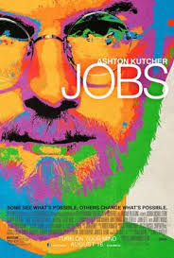 Jobs (The Movie)

Writing Prompt - Directions: After watching Jobs (The Movie), write a three paragraph essay about what company you could imagine yourself starting in your family garage. Amazon, Apple, Disney (including Pixar, ABC, & ESPN), Google, Harley Davidson, Hewlett-Packard, Lotus Cars, and Mattel Toys all started in a family garage. What would you like to start in your garage? (100 points)

