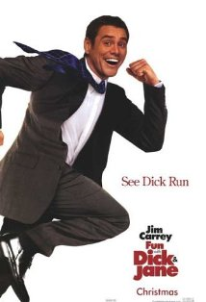 Fun with Dick & Jane
Reflective Writing Assignment
Please write three paragraphs (at least three sentences each paragraph) on the Management 1600 lessons you can draw from this film, such as One of The Five Managerial Skills; Ethical, Social, and Legal Responsibilities of Management; The Importance of Having a Contingency or Backup Plan ; or another related topic. This assignment is worth 100 points. (Please write your essay below, and on the back side of this page.)

