“Bucket” List Reflective Essay

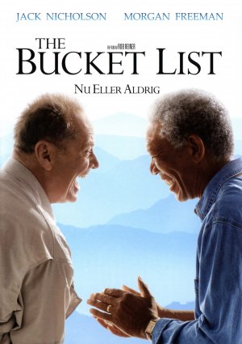
Directions: During and following your viewing of the movie “The Bucket List”, please write an essay about your bucket list. What would you like to accomplish, what would you like to do, and where would you like to visit in your lifetime. Please remember that a powerful essay contains five paragraphs, with at least three sentences per paragraph, [Introduction (Thesis Statement), Arguments For, Arguments Against, the Crunch (all the power of your position), and the Conclusion (Summary)]. You may hand write your notes below, and then use a Word Processor (Word 2014) to construct your essay which will have spell and grammar check. Spelling, syntax, grammar, and punctuation will count. Don’t forget the Six Writing Traits: Sentence Fluency, Ideas & Content, Voice, Organization, Word Choice, and Conventions. Please see the assignment rubric on the back of this page. (100 points)

Assignment Rubric

CATEGORY | 33 Points per Category | 30 Points per Category | 27 Points per Category | 24 Points per Category
Introduction (Organization) | The introduction is inviting, states the main topic and previews the structure of the paper. | The introduction clearly states the main topic and previews the structure of the paper, but is not particularly inviting to the reader. | The introduction states the main topic, but does not adequately preview the structure of the paper nor is it particularly inviting to the reader. | There is no clear introduction of the main topic or structure of the paper.
Word Choice | Writer uses vivid words and phrases that linger or draw pictures in the reader\\\'s mind, and the choice and placement of the words seems accurate, natural and not forced. | Writer uses vivid words and phrases that linger or draw pictures in the reader\\\'s mind, but occasionally the words are used inaccurately or seem overdone. | Writer uses words that communicate clearly, but the writing lacks variety, punch or flair. | Writer uses a limited vocabulary that does not communicate strongly or capture the reader\\\'s interest. Jargon or cliches may be present and detract from the meaning.
Sentence Structure (Sentence Fluency) | All sentences are well-constructed with varied structure. | Most sentences are well-constructed with varied structure. | Most sentences are well-constructed but have a similar structure. | Sentences lack structure and appear incomplete or rambling.
Commitment (Voice) | The writer successfully uses several reasons/appeals to try to show why the reader should care or want to know more about the topic. | The writer successfully uses one or two reasons/appeals to try to show why the reader should care or want to know more about the topic. | The writer attempts to make the reader care about the topic, but is not really successful. | The writer made no attempt to make the reader care about the topic.
Grammar & Spelling (Conventions) | Writer makes no errors in grammar or spelling that distract the reader from the content. | Writer makes 1-2 errors in grammar or spelling that distract the reader from the content. | Writer makes 3-4 errors in grammar or spelling that distract the reader from the content. | Writer makes more than 4 errors in grammar or spelling that distract the reader from the content.
Support for Topic (Content) | Relevant, telling, quality details give the reader important information that goes beyond the obvious or predictable. | Supporting details and information are relevant, but one key issue or portion of the storyline is unsupported. | Supporting details and information are relevant, but several key issues or portions of the storyline are unsupported. | Supporting details and information are typically unclear or not related to the topic.

