Name: _________________________ Period: _____ Date: _______________
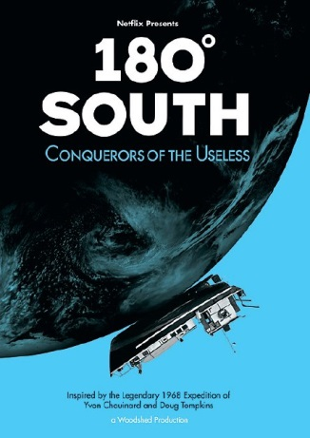
Writing Prompt: As you watch the movie, “180 Degrees South,” can you imagine putting together an epic journey to a special place in the world and establishing a world preserve that would project that place from over developments for the benefit of future generations? Please write a mini-essay (3 paragraphs) about your journey and world preserve. (100 points)

